Procurement guide
Promoting the use of biogas in transportation and logistics in City of Mikkeli
Work package 3

Mikkeli Development Miksei Ltd.

Version | 1.0
WP | 3
Deliverable
Date | 25.05.2021
Dissemination level | Public
Deliverable lead | ICLEI
Authors | Ilkka Liljander, Mikkeli Development Miksei ltd.  Janne Skott, City of Mikkeli
Reviewers | Johanna Järvinen, Mikkeli Development Miksei ltd.  Hanne Soininen, Xamk  Vuokko Malk, Xamk
Abstract | This guide helps to acknowledge the demands of sustainability, low carbon monoxide emissions and usage of biogas as a motive power in public procurement process, tenders and documents of traffic, transportation and logistics contracts in the city of Mikkeli.
Keywords | Procurement; sustainability; low emissions
License | This work is licensed under a Creative Commons Attribution 4.0 International License(CC BY 4.0).  See: https://creativecommons.org/licenses/by/4.0/

Contents
1. Introduction 2
2. The strategy for increasing the use of biogas in the city of Mikkeli 3
2.1. Background information 3
2.2. Natural gas 3
2.3. The use of biogas cars 3
3. Increasing the use of biogas through procurement 4
4. Increasing the use of biogas in different stages of procurement 5
4.1. Procurement preparation phase 5
4.1.1. Service procurement 5
4.1.2. Goods/equipment/vehicle purchases 5
4.2. Market engagement and communication 5
4.3. Market dialogue 6
4.4. The absolute requirements for service in production/ content 6
4.5. Tender evaluation criteria 6
4.6. Compensation for the service provided 7
4.7. Monitoring and controlling procurement 7
5. Examples of the Groups´s purchases in which biogas has been a requirement 7
5.1. Tendering for public transport and service transport in the city of Mikkeli 7
5.2. Tendering for Metsäsairila Ltd´s waste collection and transportation 7
6. Key vocabulary for biogas 8
7. Preparations of instructions 9
8. For more information 10

Introduction
The Directive on the Procurement of Clean and Energy-efficient Vehicles requires public organizations to increase the amount of clean and energy-efficient vehicles in public procurement of vehicles and transport services. The Directive sets targets for the step-by-step tightening of requirements by vehicle type and defining these minimum requirements of clean vehicles in public procurement. Based on the directive, a national law on the procurement of clean and energy-efficient road transport vehicles is currently being prepared and will be presented to Parliament in week 17/2021. The main sources of clean power for vehicles are electricity, hydrogen, natural gas and biogas.
In the Figure 1 below is shown the minimum share of clean and energy efficient vehicles in public procurement from August 2021 in different vehicle categories.

Vehicle categories 8/2021–2025 2026–2030
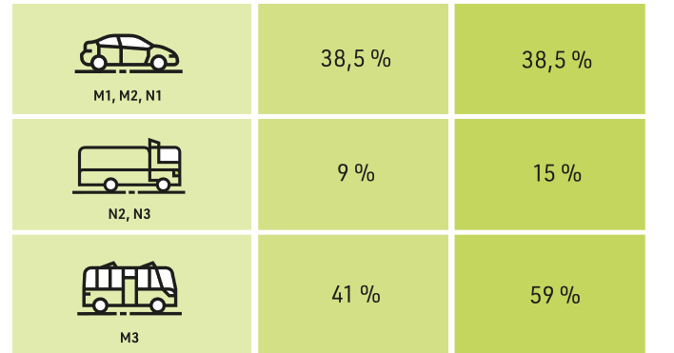
Figure 1. The minimum share of clean and energy efficient vehicles in public procurement from August 2021 in different vehicle categories (Source: Ministry of transport and communications).

The strategy for increasing the use of biogas in the city of Mikkeli

Background information
On 7 December 2015, Mikkeli City Council approved the decision to establish a biogas plant called BioSairila Ltd. BioSairila Ltd is part of a larger EcoSairila development platform. The guiding idea in EcoSairila's development work is industrial symbiosis: cooperation networks formed by several companies, in which companies add value to each other by making efficient use of produced raw materials, technology, services and energy. Increasing the production and use of biogas in Mikkeli supports the goals of the strategic programs of the Mikkeli city strategy - the Sustainable Growth program and the Vitality program, as well as in the achievement of climate and energy policy goals.

Natural gas
It should be noted that natural gas does not meet the definition of a clean energy source for vehicles in the Clean Vehicles Directive (natural gas is a fossil fuel), nor is it an energy choice under the Mikkeli Viability Program.

The use of biogas cars
The share of biogas-powered vehicles in has long been small, but in recent years the number has started to increase. The following Figure 2 presents the number of gas vehicles (left column) used in Finland by vehicle category. The statistics are shown quarterly in years 2016-2021.

Number of vehicles
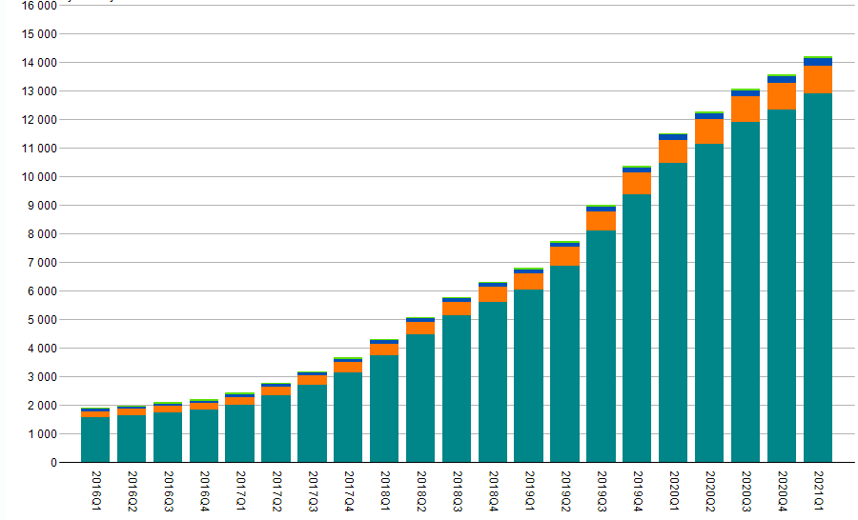
The different colours present the different vehicle categories: dark green = passenger/private car, orange = vans, blue = trucks, light green = buses
Figure 2. Presents the number of gas vehicles (left column) used in Finland by vehicle category. The statistics are shown quarterly in years 2016-2021.

Increasing the use of biogas through procurement
A significant part of the operations of the City of Mikkeli and its Group is carried out through procurement with the support of selected service and goods suppliers. The development of procurement and the goals set for it have a direct impact on the city's operations - even in short term development. The renewal and development of the Group's operations is accelerated and the process is supported by the resources of the involved companies which help introduce new operating models into the Group. The pre-acquisition phase and the market dialogue with companies playes a particularly important role in the process.

Increasing the use of biogas in different stages of procurement

Procurement preparation phase
At the beginning of each procurement preparation phase, the following basic questions should be asked, depending on whether it is a service procurement or a procurement of goods / equipment / vehicles. The basic questions are:

Service procurement
Is the provision of the service based on the utilization of vehicles?
Does the provision of the service involve the utilization of vehicles?
Additional questions:
Does / can the service provider utilize biogas vehicles in its operations?
Are the vehicles cars, vans, trucks or buses?

Goods/equipment/vehicle purchases
Can cars / machines that are rented, leased or purchased be biogas powered?
Can a supplier or its subcontractor use biogas vehicles in its delivery process?

Market engagement and communication
- Before the start of the current contract period, inform the contractor in good time of the subscriber's general objective of increasing the use of biogas in procurement. In this way service providers can plan their long-term investments in equipment better.
- Inform about the law on the procurement of clean and energy-efficient road transport vehicles and its requirements for service subscribers.
- Seek to find information on the market supply, prices and delivery times for biogas vehicles.

Market dialogue
- Launch a procurement-specific market dialogue in good time, preferably no later than 12 months before the publication of the contract notice.
- Publish at least a request for information in Hilma asking market participants for comments on the propulsion goals / preliminary requirements
- hold a discussion event to review the acquisition in question
- seek information on the market supply, prices and delivery times for biogas vehicles
- find out if propulsion conversions are possible (eg from diesel to biogas)
- discuss possible transition periods and scaling the time periods for the changes in propulsion requirements
- discuss the options for using the propulsion requirement (absolute requirement, criterion to be assessed, bonus in service charges, etc.) in the procurement in question

The absolute requirements for service in production/ content
- the biogas propulsion requirement may be made mandatory in full or partly for the equipment in the provision of the service
- note, however, the proportionality and reasionability of the requirement in terms of cost and timing
  - an oversized requirement can increase the cost of providing a service more than expected and put small businesses in an unreasonable position
  - oversized requirement reduces competition and favors large players

Tender evaluation criteria
- the share of biogas-powered vehicles in the production of the service in question may be an assessment criterion, for which additional points are given from.
  - at the same time, however, it should be noted that the voluntary use of biogas as a propellant does not ensure that the requirements of the Directive are met
  - voluntary use may be allowed, in particular where the service provider undertakes to use it for quality points in order to obtain support services related to the provision of the competitive service.
- the proportion of clean vehicles used by the producer in his other activities or in support of the provision of the service may be a criterion to be assessed which entitles the producer to additional points

Compensation for the service provided
- the provision of a service based on biogas-powered vehicles, may justify higher compensation of a contracted service

Monitoring and controlling procurement
- ensure compliance with the propulsion requirement during the contract period
- describe the control mechanism in the call for tenders and seek an arrangement whereby the service provider is responsible for providing the subscriber with a report or other evidence from time to time automatically
- failure to report the use of biogas is a sanction in the procurement contract (eg notice - contractual penalty)

Examples of the Groups´s purchases in which biogas has been a requirement

Tendering for public transport and service transport in the city of Mikkeli
In the autumn of 2020, the City of Mikkeli competed for the service production of public transport and service transport for the contract period beginning on 1 May 2021. The tender was carried out in autumn 2020, but the market dialogue was already launched in autumn 2019. The service provider was required to use four (4/11) biogas buses in the provision of the service from the beginning of the contract period. For the contract period, a bonus was also set for the excess of the minimum requirement by increasing the operating fee for the additional gas-powered bus by 7.5% and increasing the operating fee for the electric bus by 15%.

Tendering for Metsäsairila Ltd´s waste collection and transportation
In the spring of 2019, Metsäsairila Ltd competed for the disposal and transportation of mixed waste at the properties of: the City of Mikkeli, Mikalo Ltd, Mikkelin Asumisoikeus Ltd and MOAS Ltd. Metsäsairila Ltd also competed for the sparsely populated areas in Mikkeli, and the disposal of recyclable waste throughout Metsä-Sairila Ltd's operating area. The tender set an absolute requirement for the biogas propulsion requirement, extending to the equipment required to provide the entire service. In practice, this meant three biogas-powered waste trucks.

Key vocabulary for biogas
Bi-fuel
A vehicle that can run on two different fuels at different times, such as a gas hybrid car that runs on gasoline or biogas at a time.
Biogas
Biogas is a gas mixture that is formed when biomass is decomposed by anaerobic digestion.
Biomethane
Biomethane is a collective term for gases composed mainly of methane and produced from biological material.
CBGCompressed Bio Gas
pressurized biogas
CH4
Methane in the simplest hydrocarbon and alkane. It is odorless gas and lighter than air.
CHP
Combined Heat and Power
CNG
Compressed Natural Gas
CO
Carbon monoxide is a compound of carbon and oxygen that is produced, for example, by incomplete combustion.
CO2
Carbon dioxide is a compound of carbon and oxygen used by plants and is the most significant greenhouse gas.
Dual-fuel
A vehicle or machine that uses two different fuels at the same time, such as fuel oil and biogas.
LBG
Liquefied Bio Gas.
Slow refueling
The slow refueling unit includes a compressor with a refueling gun to pressurize the gas into the car's gas tank. Filling a gas tank takes several hours and is often used at home refueling points, refueling machines, and generally in vehicles that can be refueled overnight.
LNG
Liquefied Natural Gas
Mono-fuel
Monofuel means a vehicle or a machine that uses only one fuel. Usually the fuel is either gasoline or diesel. There are also bio- or natural gas-powered monofuel vehicles and machines.
Fast refueling
Compressed gas refueling method commonly used at refueling stations for public transport use.
Raw biogas
A gas mixture produced during the anaerobic digestion of organic material or in a biogas reactor of a biogas plant.
Synthetic biogas
Synthetic biogas is produced from wood gas, as the name implies, synthetically, i.e. by SBG synthesis, or more generally by methane synthesis, which is a thermochemical process.

Preparations of instructions
During the preparation of this guide, experts in charge procurement processes in the City of Mikkeli were interviewed:
Janne Skott, Mikkeli city
Aki Taavitsainen, Mikkeli city
The guide was developed with the help of iterations, in collaboration with the above-mentioned experts. Other sources of information for the development of the guide were the reports and experiences of the procurement processes as well as the comments received from companies during the market dialogue to develop the procurement process and take the circular economy into account in procurement processes. The instructions have also been checked by the city's procurement manager Jarmo Autere. The guide has also been approved for use by the city in the procurement team of the city of Mikkeli.

For more information
Sources and more information:
Biogasdata/tables/glossary:
BIOKAASUA! Käsikirja kaasukäyttöisten ajoneuvojen hankinnan ja käytön tueksi
www.circvol.fi
https://circvol.fi/wp-content/uploads/2020/05/Biokaasua_k%C3%A4sikirja.pdf
ProAgria
https://www.proagria.fi/sites/default/files/attachment/lbk_tietokortti_6.pdf
Motiva
https://www.motiva.fi/ratkaisut/uusiutuva_energia/bioenergia/biokaasu
Mirja Mutikainen Ramboll Finland: Biokaasun tuotannosta liikennekäyttöön – Missä tökkii?
https://energiavirasto.fi/documents/11120570/16249680/Biokaasu-tuotannosta-liikennek%C3%A4ytt%C3%B6%C3%B6n-Mutikainen-Mirja.pdf/9b75a422-3831-74a6-91c0-131455a20bf6/Biokaasu-tuotannosta-liikennek%C3%A4ytt%C3%B6%C3%B6n-Mutikainen-Mirja.pdf
Liikenne ja viestintäministeriö: Julkiset ajoneuvohankinnat ympäristöystävällisiksi
https://api.hankeikkuna.fi/asiakirjat/11836402-2447-4089-bcd1-dc3c04d46dbc/0a0901dc-f6bf-4a4c-847f-dd9ec9c8ca01/LIITE_20210201095930.pdf
Kaasukäyttöisen ajoneuvokaluston hankinta- ja muunnosmahdollisuudet
https://www.theseus.fi/bitstream/handle/10024/423710/Imppola_etal_Kaasukayttoisen_2020.pdf?sequence=1&isAllowed=y

